## 3AB Human Biological Science

## Reaction Time Investigation

Name: ________________________________________________________ ___________/ 20

Reaction time should not be confused with reflex time, because reacting to a stimulus involves processing of auditory or visual stimuli in the brain. A reflex action is “processed” in the spinal cord. Of course stimuli are not truly “processed” at a conscious level, but rather at an automatic and involuntary level.

A reaction time to a stimulus can vary between people, especially under certain conditions (intoxication, fatigue, stress etc).

You are to conduct an experiment into the influence of a factor of your choice and its effect on reaction time. You may choose a factor such as

* Gender
* Age
* Caffeine consumption (coffee, tea or cola)
* Physical fatigue
* Dominant vs non-preferred hand
* Distractions such as listening to music

The factor you choose must be practical enough to complete during class time. (no not alcohol!)

**Task 1:** **Research** the factors affecting reaction times and write a ½ page report on what you have found out. You must include your references.

**Task 2:** **Investigation:** In a group of no more than 3 people, determine your experimental factor and design your experiment. Draw up a results table to enter your data. This must be able to be completed in one lesson.

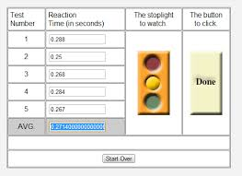In order to determine a person’s reaction time, a Reaction Timer is available on <https://faculty.washington.edu/chudler/java/redgreen.html>

#Note: Participants should not practise using the Reaction Timer before they start trials.

For consistency, participants will test their reaction times by completing **5 trials of 5 tests each**.

**Task 3:** **Assessment.** Using your data you will complete an in-class assessment based on your investigation and the theory on which it is based.